# Project proposal for

# DST &Texas Instruments Inc.

# India Innovation Challenge Design Contest 2016

# Anchored by IIM Bangalore

# SMART NAVIGATION SYSTEM FOR THE VISUALLY IMPAIRED

# SSN COLLEGE OF ENGINEERING

|  |  |  |  |  |
| --- | --- | --- | --- | --- |
| Name | College ID/Roll No. | UG/PG | Course/Branch | Semester |
| NAVEEN NARAYANAN | 312214106066 | UG | BE/ECE | 5 |
| V.PRAKASH | 312214106073 | UG | BE/ECE | 5 |
| K. VIMAL RAJ | 312214106125 | UG | BE/ECE | 5 |
| P.SIVASANKAR | 312214106102 | UG | BE/ECE | 5 |
| S.SOMASUNDAR | 312214106104 | UG | BE/ECE | 5 |
| (FACULTY)  Dr. R. RAJAVEL  Dr. S.JOSEPH GLADWIN |  |  |  |  |

# Project Abstract

Visually challenged people all over the world face difficulties in navigation, particularly in an unknown environment. Most of them use normal cane to navigate for their regular activities. They face challenge only when they want to navigate in an unknown environment, where they need help from others. Hence there is a need for a system to guide them while navigating in an unknown environment. This project aims to develop a smart navigation system using the current communication technology for visually impaired people to navigate without any help from others. The proposed system will have a smart hand held device with Wi-Fi transceiver and Wi-Fi access points. When the visual impaired people goes near to the Wi-Fi access point, the device which they have and Wi-Fi access point get paired and the MAC address of the Wi-Fi access point representing that location is sent to the server and the corresponding audio file will be played to guide them to navigate. The proposed system will also have a cane with ultrasonic sensors for obstacle detection and intimate them via an audio message; In turn makes the system as a smart navigation unit for visually impaired people.

# Keywords:

Wi-Fi

Microcontroller

Sensors

Voice Message

Smart Cane

Headphone

# Team Members – Roles & Responsibilities

Teams must share the list of all members and explain their role in the team as per following category

* Marketing
* Technical,
* Operations, &
* Any other role(s) as applicable

Teams to provide justification for each team member's role and cite examples as required to support your reasoning.

|  |  |  |  |
| --- | --- | --- | --- |
| **S.No.** | **Student Member Name** | **Role (Choose one of the following – Marketing, Technical, Operations & Other Roles as applicable)** | **Justification** |
| 1 | NAVEEN NARAYANAN M | TECHNICAL | In charge of designing the handheld device with microcontroller |
| 2 | SOMASUNDAR | TECHNICAL | Responsible for designing the smart cane |
| 3 | VIMAL RAJ | OPERATIONS, TECHNICAL | Sets up the server with different audio files |
| 4 | SIVASANKAR | MARKETING, TECHNICAL | Compares prices of similar products available in the market |
| 5 | PRAKASH | MARKETING, OPERATIONS | Sets up Wi-Fi system in the building |

# Market Analysis

Teams to provide a detailed study about the customer needs [in context of India] leading to identification of the problem being solved which coversthe Total Addressable Market (TAM), Serviceable Addressable Market (SAM), study of existing solutions [Competition]and opportunities for enhancing/improving the solution leading to the proposed solution.

Teams to validate their analysis with usinggraphs, illustrations and quantitative data from different sources as applicable.

1. Customer Need Identification - <Teams to present thier case & Share information>
2. Serviceable Addressable Market (SAM) Identification & Justification - <Teams to share details of their SAM and support with analysis as applicable>
3. Product Differentiation w.r.t. Competition& Justification - <Teams to Highlight the differentiated featues of their product w.r.t. to completion/existing product with justification>
4. Understanding of your customer & user- <Teams to identify their customer & user and share their product positioning to enable ease of adoption for both of these >

***Note:*** Users refer to people using the product/service, and a customer is one who pays for the product/services***. Depending on product both could be same or different.***

1. Distribution Channel Identification - <Teams to share how would you deliver the product/service to the customers/users>

# Proposed Design

Objective –

The objectives of this project are to:

1. Setup a database server that stores the different audio files with directions to different places.
2. Place WI-Fi routers at different points and connect them to the server through a common switch.
3. Pre configure the server with the MAC addresses of the router
4. Place the sensors along with the microcontroller on a cane to detect obstacles.
5. Design a smart standalone system with a 3.5mm audio jack.

# Proposed Solution

* 1. Block Diagram -

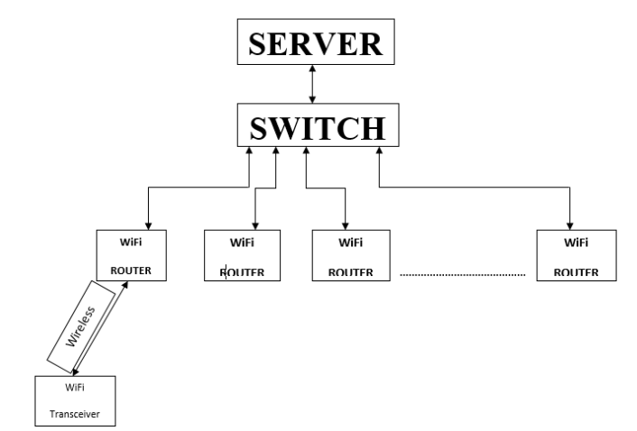

Component Used -

|  |  |
| --- | --- |
| TI Part Number  (link all the parts to their respective product page on the TI website) | How is it being used in the proposed solution? Explain its role/functionality |
| Part 1 TDC100 | Ultrasonic sensor-Used to detect nearby obstacles |
| Part 2 CC3100 MOD www.ti.com/product/cc3100MOD/description | Microcontroller |
| Part 3 |  |
| Part 4 |  |
| Part 5 |  |

|  |  |
| --- | --- |
| Non - TI Parts | How is it being used in the proposed solution? Explain its role/functionality |
| Part 1 PC | Used to setup the server |
| Part 2 Wi-Fi Router D-Link | Used to find the location of the server |
| Part 3 |  |
| Part 4 |  |
| Part 5 |  |

# Innovativeness of the Proposed Solution

Teams have to explain the uniqueness/differentiation of their proposed solution with respect to the existing competition in the current scenario. Teams can differentiate their proposed solution on the following vectors – size, power, performance, cost, functionality& others as applicable

# Impact of the proposed solution

The proposed solution will provide better safety measures for the visually impaired in terms of navigation. It will provide better guidance for navigation and obstacle free movement for the visually impaired people. It will also morally increase their confidence while navigating in their in unknown locations. This will also reduce their dependency on others and this will change the mindset of the common people. Some people consider the visually challenged as a liability to the society and this will change their perception.

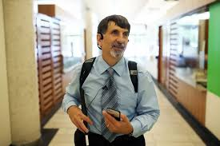 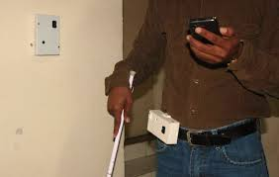

# Feasibility

India has the world’s largest population of visually impaired. This project will be highly productive in India due to this reason. It will offer guidance to almost 15 million of the people in this country.